2B Displaying Single Data Sets – Lesson 3
Statistics – Graphs with Microsoft Excel.

Name: _________________
- What are the benefits of drawing charts with Microsoft Excel?

- List the seven types of graphs available when one clicks on the insert icon.

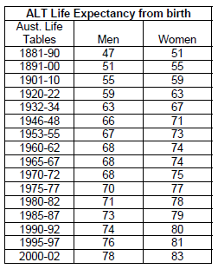
  - ____________________________

  - ____________________________

  - ____________________________

  - ____________________________

  - ____________________________

  - ____________________________

  - Other.

- Chart the ALT Life Expectancy from Birth as a line graph and print.
[Source: www.findem.com.au/factsheets/lifeexpectancyfactsheet.pdf]

  - For men and women on separate charts.
[Hint: put a single quote before the date. i.e. ‘1881-90]

  - Why would it be a good idea to plot both men and women on the same chart.

- Do a Google search to find the NRL, AFL, Soccer OR Basketball Ladder. Display as a column graph and Print.

- Why did we use a ‘column graph for the NRL’ but used a ‘line graph for life expectancy’.
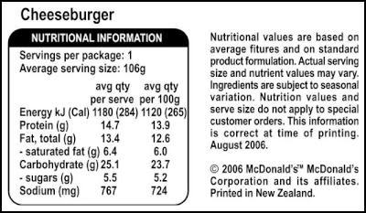
- Graph the Protein, Fat total, Carbohydrate and Sodium in a Kiwi Cheese-burger as a 3D Pie chart.

[Source: http://www.futilebrands.com/food-drink/mcdonalds-launches-nutrition-facts-label]

- Graph the ‘Avg Qty/100g’ sugar content for each of the following McDonalds Burgers.

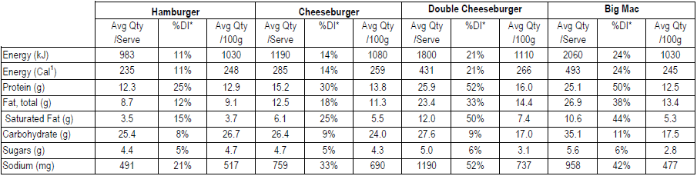

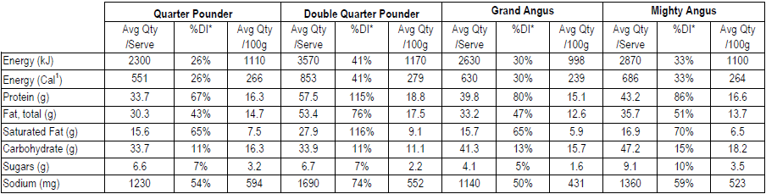

[Source: http://mcdonalds.com.au/sites/mcdonalds.com.au/files/images/Nutrition-Information-8-September-2010.pdf]

Which has the least amount of sugar?

